Behaviour Policy

April 2019

Contents

Page

3 Aims and Aspirations

4 Our Values

5 Enabling our Aims and Values

6 Behaviour Management at Coety Primary School
      - Logical Consequences
      - Managing day to day behaviour
      - Managing conflict day to day
      - Managing intentional behaviour
      - Tracking unacceptable behaviour
      - Parental Involvement

8 Bullying and Targeted Behaviour
- Roles and responsibilities

11 Parental Concerns
- Open Communication

12 Additional Information
- Police Involvement
- Restorative Practice
- ELSA
- Wellbeing Plans
- Consequence Slips

Our Aims
At Coety Primary School we aim to…
- Provide every child with the opportunities, experiences and aspiration to achieve their potential.
- Lead by example, working in partnership with all role models in our children’s lives to enable our expectations for behaviour to be met.
- To ensure every child's wellbeing to enable their readiness to learn.
- Enable children to take responsibility for their own behaviour and their actions.

We aspire to be …
Ambitious, capable learners ready to learn throughout our lives:
- Confidently communicating, listening to others and sharing what we think.
We aspire to be …
Ethically informed citizens, ready to lead fulfilling lives as valued members of society:
- Use information around us to build our views.
- To know our rights.
- To know how our actions and choices can affect others.
We aspire to be…
Healthy, confident individuals ready to be citizens of Wales and the world:
- To make decisions that will keep us safe.
- To know how to treat and support those we care about.
- To show others we can be independent.
- To face challenges that we find difficult.
We aspire to be …
Enterprising, creative contributors ready to play a full part in life and work:
- To solve problems.
- To work in teams alongside others.
- To share our ideas and feelings.
- To always help others to be the best they can be.
Our Values
As a school we believe every child is shaped by ‘nature’ and ‘nurture’.
- Every child is different…
- Every child deserves a chance to succeed
- One size does not fit all…
There is always a reason why a child behaves in a certain way.

Our school policy is built on values. You can bend and break rules! You cannot bend or break values!

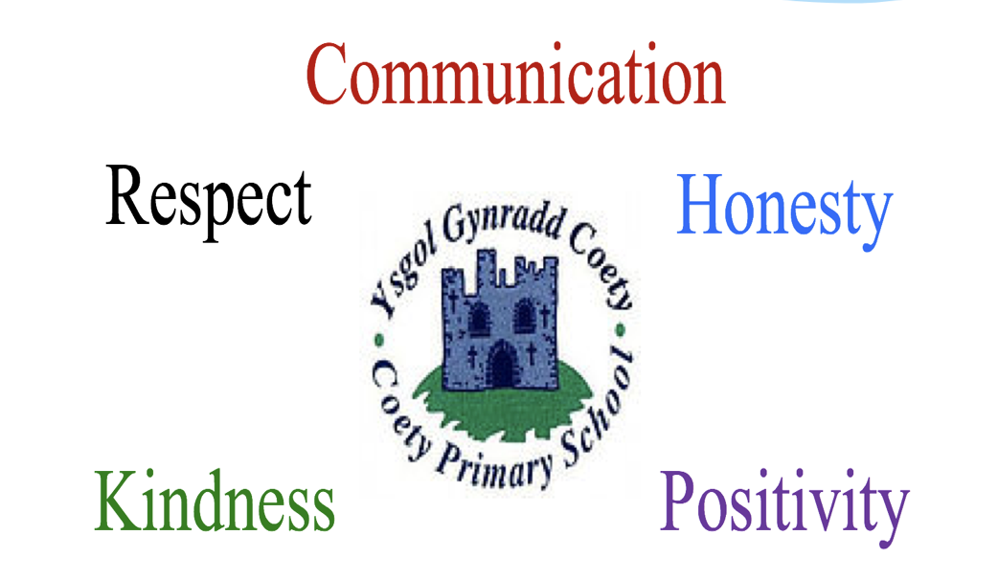

Enabling our Aims and Values
We enable our policy through:
- Consistent expectations from all adults
- Positive reinforcement of values
- Parental support
- Class charters
- Emotional Literacy Support Assistants (ELSA trained staff)
- Circle time to consider and discuss social and emotional scenario’s
- Peer Mediators
- Daily ‘checking in’ within every class to enable staff to gauge pupil wellbeing
- Developing Social and Emotional Attitudes to Learning through curriculum activities (SEAL)
- Ensuring Rights Respecting Values through raising children’s awareness of their rights.
- Use of Restorative practices
- Listening to pupil voice
- Wellbeing plans
- Cool down areas in the Foundation Phase and KS2.

We celebrate children’s brilliance…
- Praise with reference to school values
- Weekly Star of the Week awards
- Individual class award systems
- ‘Class Dojo’ digital reward system
- Friendship awards
- Acts of Kindness awards
- Stickers, reward boxes and certificates
- Golden Time
- Achievement Wall – Celebrating children’s achievements from outside school

Behaviour Management at Coety Primary School
Logical consequences:
- Helping children to develop internal controls and to learn from their mistakes in a supportive atmosphere.
Examples of logical consequences:
- You break it – You fix it!
- Expectations not met – Lose that privilege
E.g. Pushing in the line – go to the back
E.g. Not following the rules in games – miss a session
E.g. Damaging equipment – miss out on use
Managing day to day behavior and conflict:
- Not listening, not following class charters, being disruptive and impacting on the learning of others.
- Name calling, unkind words, arguing, verbal and physical confrontation, rough play, rough games and sports.
If an incident results in physical injury, the parents / carers of the victim and perpetrator will be informed by the class teacher.
Responding to behaviour:
Verbal Warning 1
- Gain attention, pause then give direction.
- State what you want the child / children to do, not what you want them to stop doing.
- Speak firmly but calmly.
Verbal Warning 2
- Make viable adjustments within context. E.g. Separate children on to different activities.
- Use language of choice, providing two choices.
FPh Example: You pick the blocks up now or you pick them up at playtime.
KS2 Example: You finish your work now or you do it at playtime.
Action if Verbal Warning 2 not Achieved:
- Use of restorative questions and discussion appropriate to child’s age.
- Time out, sit with the teacher for an identified period, spend time in another class or loss of privileges.
Consequences will take individuals wellbeing needs into account.
Nursery and reception pupils will not be sent to another class but may be taken to a senior leader for a short period of time to reflect on their actions.
If a child receives a consequence, a slip detailing the incident and consequence will be sent home. In the instance of a nursery or reception child experiencing time out or being directed to sit with the teacher, parents will be contacted by phone or spoken to directly at the end of the day. An incident slip will not be sent home.
Incidents for nursery and reception children will be logged by staff on individuals’ forms within the Behaviour Log folder to ensure patterns of behaviour are tracked.
If a consequence slip is being sent home for the first time, parents / carers will be contacted by phone or directly at the end of the day to explain what has happened and why a consequence slip was given.
Managing intentional behaviour:
- Using unkind hands and / or unkind feet with intention to cause harm.
Responding to behaviour:
Incidents will be investigated and action taken accordingly. If there is no doubt that unkind hands and / or unkind feet have been used with intention to cause harm, an internal exclusion will take place.
Consequences will take individuals wellbeing needs into account.
If a child is given an internal exclusion, a slip detailing the incident will be sent home.
In the instance of a nursery or reception child demonstrating intentional behaviour, parents will be contacted by phone or spoken to directly at the end of the day. A consequence slip will not be sent home.
Incidents for nursery and reception children will be logged by staff on individuals’ forms within the Behaviour Log folder to ensure patterns of behaviour are tracked.
If a consequence slip is being sent home for the first time, parents / carers will be contacted by phone or directly at the end of the day to explain what has happened and why a consequence slip was given.
The parent / carer of the victim will be informed by the class teacher.
Internal Exclusion:
- Older children sent to another class for one session with learning to complete.
- Younger children will sit with the class teacher or be taken to senior leader to reflect on their actions.
Repeated intentional behaviour:
- Graduated increase of sessions in another class.
- A Wellbeing Plan will be created with the child and shared with their parents/carers.
Aggressive intention to harm:
- Fixed term exclusion
Incidents will be investigated and action taken accordingly. If there is no doubt of aggressive intention to harm, a fixed term exclusion will take place.
The parent / carer of the victim will be informed by the class teacher.
The parents of the perpetrator will be contacted by the Head teacher or the most senior teacher in their absence who will make it clear that they are acting on behalf of the Head teacher. A letter detailing the reason for the exclusion, the period of exclusion and return to school date will be detailed along with a time to meet with the Head teacher or Deputy Head to discuss strategies to support the child on their return to school.
Exclusion is not a solution to negative behaviour but a means by which to safeguard the child, other children and staff.
Tracking unacceptable behaviour:
- If a child has a consequence, an internal or fixed term exclusion, it is logged in the school Behaviour Log.
- The nature of the behaviour and the consequences are recorded on individual tracking sheets.
- The Behaviour Log is monitored weekly and reviewed half termly by a designated member of staff. Individuals tracking sheets are reviewed and patterns in behaviour analysed, investigated and next steps planned.
Parental Involvement
- If a child has a consequence, a slip detailing the incident will be sent home.
- Parents are required to acknowledge these slips with a signature, returning them to school. This will ensure open lines of communication and will establish partnerships with parents.

Bullying and Targeted Behaviour
What is Bullying?
Bullying is repeated and targeted action taken by one or more children with the deliberate intention of hurting another child, either physically or emotionally.
Aims and Objectives
Bullying and targeted behaviour in all forms, including cyber bullying, is unacceptable and wrong. We therefore do all we can to prevent it through our school ethos in which bullying is regarded as unacceptable. It will not be tolerated.
We aim to make all those connected with the school aware of our opposition to bullying, clearly defining each person’s responsibilities with regard to the eradication of bullying in our school.
It is our intention to provide an environment where children feel confident and safe to learn and grow. Pupils have the right to learn in a supportive, caring and safe environment without fear or the anxiety of being bullied or targeted.
Equality Act 2010
Everyone is entitled to equality of opportunity, including those with protected characteristics as mentioned in the 2010 Equality Act and Human Rights Act 1998.
Staff practice an equal opportunities philosophy, which is reflected in the ethos of the school as well as in the formal and informal curriculum. In all subjects we strive to avoid direct discrimination, indirect discrimination and discrimination arising from disability, also making reasonable adjustments for disabled pupils.
Further information can be found within our Strategic Equality Plan.

The role of the children
Pupils are encouraged to tell a trusted friend or adult if they feel they are being bullied or targeted. Opportunities to share worries through other means like the use of a “worry box” or “worry monster” are available within classes if children cannot use their words to communicate their emotions.
Pupils are invited to share and discuss their views about a range of school issues, including bullying.
It is the responsibility of the children to behave in line with our school rules in the classroom and at break times. They are to be respectful to all other children and adults in the class.
The role of Governors
The governing body supports the head teacher in all attempts to eliminate bullying and targeted behaviour. Any incidents of bullying that do occur are taken very seriously and are dealt with appropriately. The governors require the head teacher to keep accurate records of all incidents of bullying and targeted behaviour, reporting on request about the effectiveness of school anti-bullying strategies.
The governing body responds within ten days to any request from a parent to investigate incidents of bullying. In all cases, the governing body notifies the head teacher and asks him/her to conduct an investigation into the case and to report back to a representative of the governing body.
The role of the head teacher
It is the responsibility of the head teacher to implement the school behaviour policy and to ensure that all staff (both teaching and non-teaching) are aware of the school policy and know how to deal with incidents of bullying and targeted behaviour.
The head teacher ensures that all children know that bullying and targeted behaviour is wrong and unacceptable. The head teacher draws the attention of children to this fact at suitable moments. For example, if an incident occurs, the head teacher may decide to use assembly as a forum in which to discuss with other children why this behaviour was wrong.
The head teacher ensures that all staff receive sufficient training to be equipped to deal with all incidents of bullying and targeted behaviour.
The head teacher sets the school climate of mutual support and praise for success, so making bullying less likely. When children feel they are important and belong to a friendly and welcoming school, bullying is far less likely to be part of their behaviour.
The role of the teacher
Teachers take all forms of bullying seriously, and intervene to prevent incidents from taking place. They keep their own records of all incidents that happen in their classes. If they become aware of any bullying or targeted behaviour taking place between members of a class, they deal with the issue immediately. This may involve support for the victim and consequences for the child/children who have carried out the bullying / targeted behaviour. We spend time talking to the child who has bullied or targeted others and explain why the action of the child was wrong. We endeavour to help the child change their behaviour in future.
If a child is involved in bullying or targeting other children, we invite the child’s parents into the school to discuss the situation. In more extreme cases, for example where initial discussions prove ineffective, the head teacher may contact and seek support from external support agencies. Teachers attempt to support all children in their class and to establish a climate of trust and respect for all. By praising, rewarding and celebrating the success of all children, we aim to prevent incidents of bullying.
The role of parents
Parents who are concerned that their child might be being bullied or targeted, or who suspect that their child may be the perpetrator of bullying or targeted behaviour, should contact their child’s class teacher immediately. Parents have a responsibility to support the school’s policy and to actively encourage their child to be a positive member of the school.
Strategies to reduce bullying and targeted behaviour
The following will be used to prevent and reduce incidents of bullying and targeted behaviour:
- Co-operative group work
- Circle Time
- Restorative practices
- Playground Peer-mediation
- Friendship Stops
- ELSA support
- Anti-Bullying Week
- Community Police liaison
- Direct and indirect discussions through areas of the curriculum e.g. PSE, Literacy, Drama, History, RE and SEAL.
- Workshops – Show Racism the Red Card

Parental concerns
Open Communication
- See class teachers first if you have questions about progress, class work, bullying, friendships, transition, dietary issues or behaviour.

- Ask to speak to a senior leader if you have spoken with the class teacher but feel that the issue remains or you are informing the school of circumstances that affect your child’s well-being (where a wider staff need to know).

- Ask to speak to the head teacher if you have spoken with a senior leader and you feel that the issue remains.

Additional Information
Police Involvement
Within communities police officers undertake a number of different roles to provide an effective policing service for schools. The main type of officer that we as a school have contact with are School Community Police Officers (SCPO’s).
These officers deliver lessons and provide supportive policing in schools. They are deployed to ensure that a uniform, structured and professional programme is delivered to all children and young people in Wales.
The officers are required to be fully involved with the day to day life of schools and assist with problems that require police attention or advice.
The Guidelines for Schools and School Community Police Officers Working Together: School Behaviour and Incident Management document http://www.schoolbeat.org/en/teachers) gives detailed information about when and how the SCPO can be utilised in schools.
Further Information for parents: http://www.schoolbeat.org/en/parents/know-the-programme/national-events/the-school-crime-beat-protocol/

What is Restorative Practice?
To support children in thinking through their behaviour, its consequences and what they can do to make things better.
‘Restorative practice is all about developing, maintaining and repairing relationships, building a community based around empathy and self-learning, where children take responsibility for their behaviour.’
Chris Straker
Examples of Restorative Questions
What has happened?
What part did you play in it?
What would _______ say had happened?
What could you have done differently?
Who was hurt / affected?
Which school values have not been followed?
What do you think needs to happen now?
What can you do to repair the harm?
How can you help yourself to improve for next time?
Is there anything we can do to help you?

What is ELSA?
There will always be children and young people in schools facing life challenges that detract from their ability to engage with learning, and some will require greater support to increase their emotional literacy than others. ELSA is an initiative developed and supported by educational psychologists. It recognises that children learn better and are happier in school if their emotional needs are also addressed.
We are lucky enough to have three qualified Emotional Literacy Support Assistants at Coety Primary School. They have been trained to plan and deliver programmes of support to pupils who are experiencing temporary or longer term additional emotional needs. The majority of ELSA work is delivered on an individual basis, but sometimes small group work is more appropriate, especially in the areas of social and friendship skills. Sessions are fun. They make use of a range of activities such as games, role-play with puppets, arts and craft.
ELSA sessions take place in our 'ELSA room' which provides a calm, safe space for the child to feel supported and nurtured.
In ELSA we aim to provide support for a wide range of emotional needs:
  - Recognising emotions
  - Self-esteem
  - Social skills
  - Friendship skills
  - Anger management
  - Loss and bereavement
How does ELSA work?
- Children are usually referred for ELSA support by their class teacher, Senior Leaders or ALNCo. With the programme aims in mind we then plan support sessions to facilitate the pupil in developing new skills and coping strategies that allow them to manage social and emotional demands more effectively.
- 6 to 8 sessions lasting from 30 - 45 minutes once a week.

Supporting - Not Fixing
- Remember, ELSAs are not there to fix children's problems. What we can do is provide emotional support.
- We aim to establish a warm, respectful relationship with a pupil and to provide a reflective space where they are able to share honestly their thoughts and feelings.
- It needs to be appreciated that change cannot necessarily be achieved rapidly and is dependent upon the context and complexity of the presenting issues. For children with complex or long-term needs it is unrealistic to expect ELSA intervention to resolve all their difficulties, however support will be designed to target specific aspects of a child's need.

What is a Wellbeing Plan?

Wellbeing plans are created to support learners with managing their own behaviour.
They are written with the child, shared with parents and all staff to ensure a consistent approach to managing behaviour issues.

Wellbeing Plans identify…
- Triggers to the child’s behaviour.
- The behaviour demonstrated by the child if a trigger is initiated.
- The child’s target to support them in managing their behaviour.
- Steps to success which support the child in managing their behaviour.
- Consequences specific to the child’s behaviour if they do not follow their steps to success.
- Once reviewed and understood by the child, the Wellbeing plan is then signed by the child, their parent and teacher.
- Wellbeing plans are then placed within a central location in the classroom and in the staffroom so all staff are aware of how to support specific individuals across the school.
